**Website Project: Logo & Style Guide:**

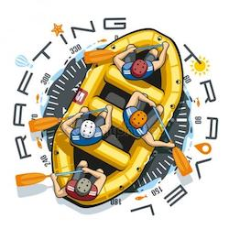**Logo:**

**Color Palette:**

Primary-Color - b5e2fa – Light Blue

Secondary-Color - 00171f - Black

Accent1-Color - f18701 - Orange

Accent2-Color - ffd400 – Yellow

**Fonts:**

**Heading-font:** Passion One

**Text-font:** Neuton

<https://coolors.co/b5e2fa-00171f-f18701-ffd400>